Testing Table
Object | Input | Expected Output | Actual Output
Exit Button | Click | Program closes | As expected  No evidence
Clear Button | Click | All textboxes reset text | 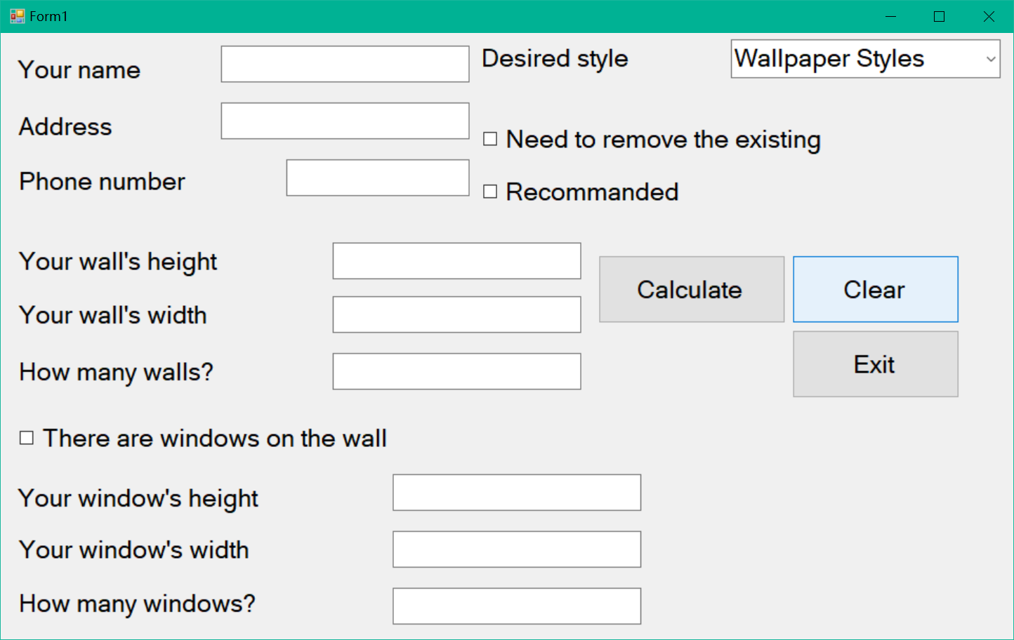
Calculate Button | Click  Wall Height = 6  Wall Width = 4  Walls = 8  Window Height =1  Window Width = 1  Windows =8  Desired style= flamingo  Removing = Ture  Recommended= Ture | Form1 hides  Form2 shows  Total area=184  Rolls = 27  Rolls Cost =$ 11434.50  Prepping Cost =$ 1840.00  Labour Cost = $ 3680.00  Removing Cost = $ 920.00  Job Cost = $ 6440.00  Discount = $ 893.73  GST = $ 1698.08  Final cost = $ 18678.87 | 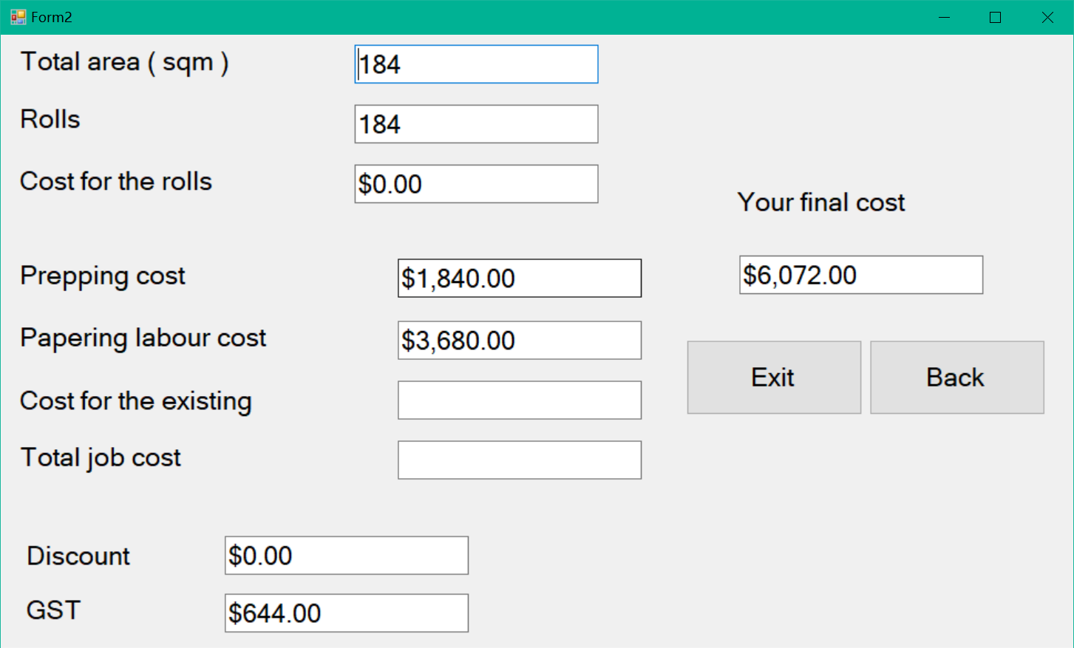  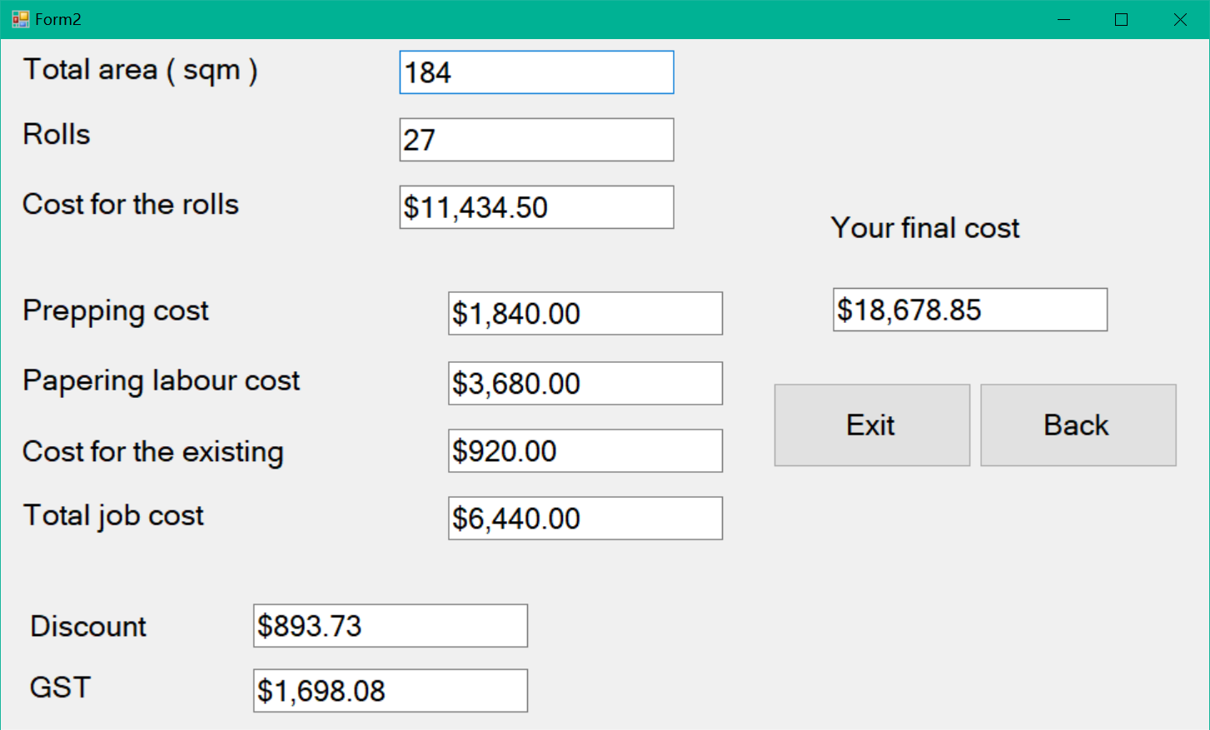
Back Button | Click | Form1 shows  Form2 hides | 